**CHE517 ADVANCED PROCESS CONTROL**

**FINAL EXAM**

Professor Shi-Shang Jang Jan. 4, 2017

**Problem #1 Interpretation: (20%)**

(1) Zero order hold

1. Phase Angle
2. Ratio Control
3. Amplitude Ratio
4. Z-transform

**Problem #2 (20%)**

For the stripping section of a distillation column shown below, the objective is to maintain the bottom’s purity at a desired value. The objective is commonly attained by controlling the temperature in one of the trays (the column pressure is assumed constant) by using the steam flow to the reboiler as the manipulated variable. A usual “major” disturbance is the feed flow to the column.

1. Sketch a feedforward/feedback control scheme to compensate for this disturbance; describe it briefly.
2. Briefly describe the dynamic tests that you would perform on the column in order to tune the feedback controller and the feedforward controller. Would you expect the dynamic compensation on the feedforward controller to be a net lead or a net lag?

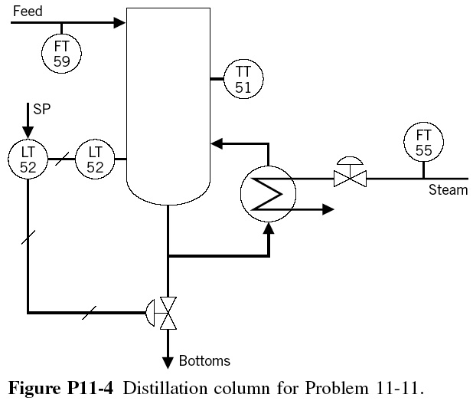

**Problem #3 (20%)**

Derive the discrete transfer functions of the following open-loop systems with a zero order hold(sampling time=0.5):

(1) $G(s)=\frac{e^{-s}}{{4s}^{2}+3,6s+1}$



(2)

**Problem #4 (20%)**

Consider the process shown below for drying phosphate pebbles. A table feeder transports the pebble-water slurry into the bed of the drier. In this bed the pebbles are dried by the direct contact with hot combustion storage. It is most important to control the moisture of the fracture into fine dust resulting in possible loss of material. If too wet, they may form large chunks, or clinkers, in the silo.

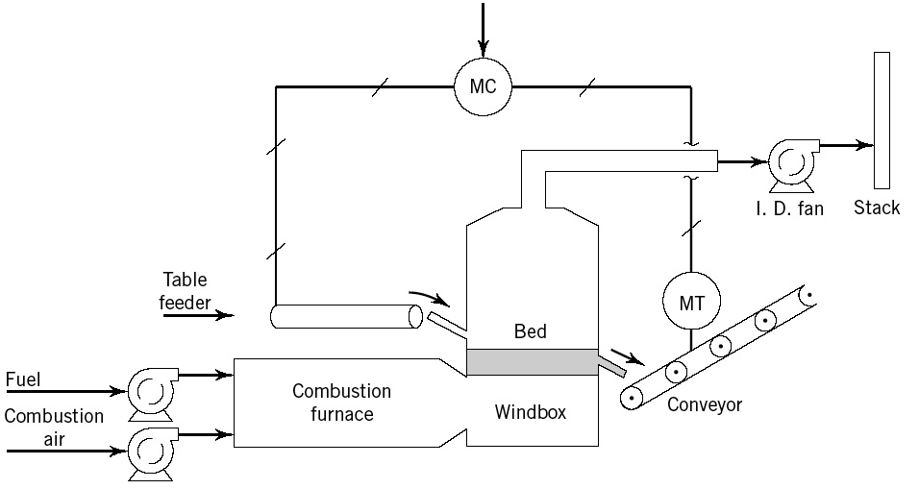

It is proposed to control the moisture of the exiting pebbles by the speed of the table feeder, as shown the above figure is directly proportional to its input signal. The moisture of the inlet pebbles is usually about a range of 1 to 5% moisture. An important disturbance to this process is the moisture of the inlet pebbles.

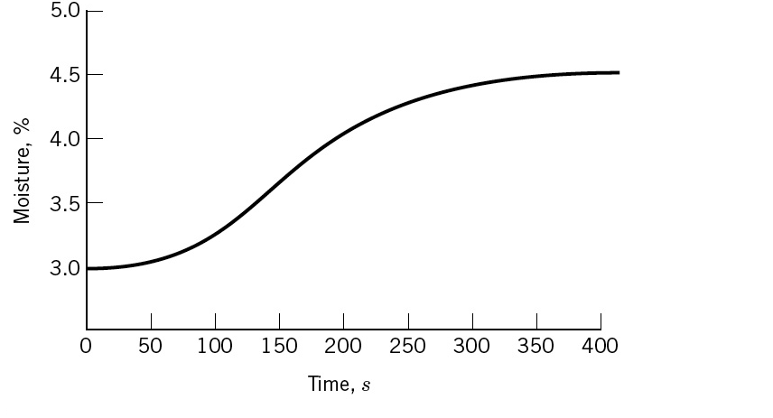

1. Above figure shows the response of the outlet moisture to an increase of 8% in control. Approximate the process curve by a first order plus dead time model. Use the method of reaction curve.
2. Draw a complete block diagram of the control loop showing all units. Include the disturbances.
3. Determine the tuning of a PID controller of a quarter decay ratio criteria. ()

**Problem #5 (20%) Take home**

Consider the process shown below :

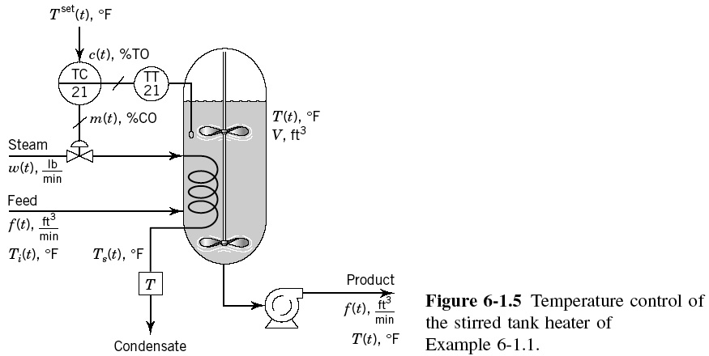

with the following parameters

Steady states: $\overline{T}=150℉;\overline{T}s=230℉;\overline{f}=15ft^{3};\overline{w}=42.2lb_{steam}$, ${\overline{T}}_{i}=100℉$

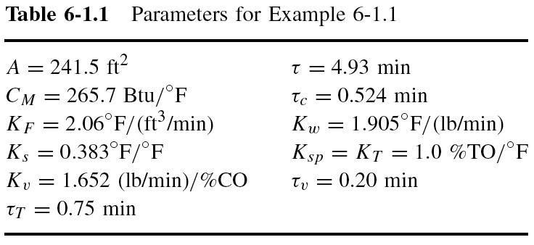

And V=120 $ft^{3}; ρ=\frac{68lb}{ft^{3}};C_{p}=\frac{0.8Btu}{lb}℉; λ=966Btu/lb_steam$

(1) Perform SIMLINK modeling for this process.

(2) Derive the total linearized model for the steam to the measured temperature.

(3) Get a reaction curve using a step change in the input signal.

(4) Tune a PID controller using the approximate model.

(5) Derive analytical feedforward controller using the linearized model.

(6) Compare the performances of feedforward controller with the previous PID controller.